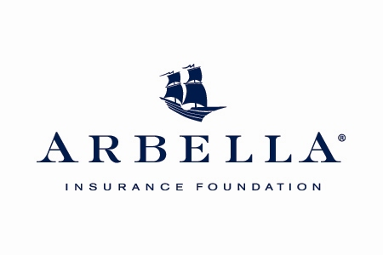

[AGENCY NAME] Contributes to Hunger Relief Program

Arbella Insurance Foundation’s “Let’s Drive Out Hunger” Initiative
Now in its Fifth Year

[LOCATION], Mass. – [DATE] -- [AGENCY NAME] today announces that it has donated $[DOLLAR AMOUNT] to the [FOOD PANTRY OR SHELTER NAME] as part of the Arbella Insurance Foundation’s “Let’s Drive Out Hunger” program.

Now in its fifth year, Let’s Drive Out Hunger aims to alleviate the increasingly prevalent issue of food security in Massachusetts. The program pools contributions from agencies with a matching gift program in which Arbella matches donations from any of its nearly 500 independent agents. This year, in recognition of Arbella’s 25th anniversary year in 2013, Arbella’s Foundation is increasing its match to three-to-one, up to $1,000 per agency. Over the past four years, Arbella and its partner agents have contributed more than $280,000 to help many of the 400 emergency food programs, soup kitchens, food pantries and food banks across 130 Massachusetts communities.

“Given the economy, hunger is hitting home in our communities more than ever before. More and more families in our neighborhoods are struggling today to secure food and, consequently, food pantries here in [TOWN/COMMUNITY] and other parts of the state are in dire need of donations,” said [AGENCY SPOKESPERSON], [TITLE] for [AGENCY NAME]. “We’re so proud to be contributing to this important effort to drive out hunger and hope other businesses will follow suit. It’s part of our commitment to giving back to our community in meaningful ways.”

A Greater Boston Food Bank study reveals how the economic downturn of the past few years has increased the need for food assistance nationwide and statewide, as poverty and food security are connected. The food bank increased its food distribution by 3.5 million pounds in 2011.

Similarly, a Project Bread Status Report on Hunger in Massachusetts notes that 615,000 state residents now struggle to provide food for their families amidst unemployment, foreclosures and lost savings.

“Giving back to the local community is part of our corporate citizenship, and I like to think it’s part of our DNA. It is the reason we formed the Arbella Insurance Foundation, and we can think of no better time to make a push to combat hunger,” said John Donohue, chairman, president and CEO of the Arbella Insurance Group and chairman and president of Arbella’s Foundation. “Our agents throughout New England are incredibly active in their communities. By bundling our contribution with theirs, we can effectively quadruple the donations they make to needy organizations in their area.”

About [AGENCY NAME]

[AGENCY BOILERPLATE]

About the Arbella Insurance Group and the Arbella Insurance Foundation
Established in 1988, the Arbella Insurance Group (www.arbella.com) is a company with more than $600M in revenue with approximately $1B in assets, headquartered in Quincy, Massachusetts. Arbella is a customer-focused regional property and casualty insurance company, providing personal and business insurance in Massachusetts and Connecticut, and business insurance in Rhode Island and New Hampshire. Arbella Insurance Group founded the Arbella Insurance Foundation in 2004. The mission of Arbella’s Foundation is to engage in activities and to support not-for-profit organizations that have a significant positive impact on the people and communities served by Arbella.

# # #

For more information:
[INSERT AGENCY CONTACT INFORMATION]

